CSA1304 - THEORY OF COMPUTATION
LABORATORY EXPERIMENTS

Name: Sanjay Manesh M
Reg No: 192511362

1. Write a C program to simulate a Deterministic Finite Automata (DFA) for the given language representing strings that start with a and end with a

Program Code
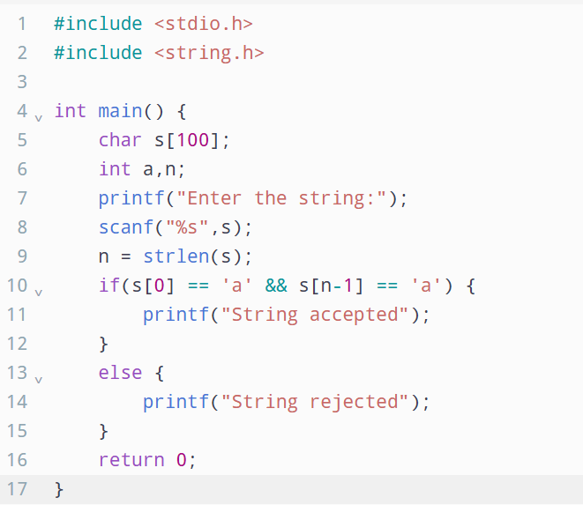

Output
